Northover's VT
sponsored by Rudy Project

present their

Easter 10 Mile Time Trials
Event Sponsored by:
Yellow Ltd
Rudy Project

Monday 5th April 2021

Course S26R/10

(Promoted for and on behalf of Cycling Time Trials under
their Rules and Regulations)

IN THE INTEREST OF YOUR OWN SAFETY
Cycling Time Trials and the event Promoters strongly advise you to wear
a HARD SHELL HELMET that meets an internationally
accepted safety standard.

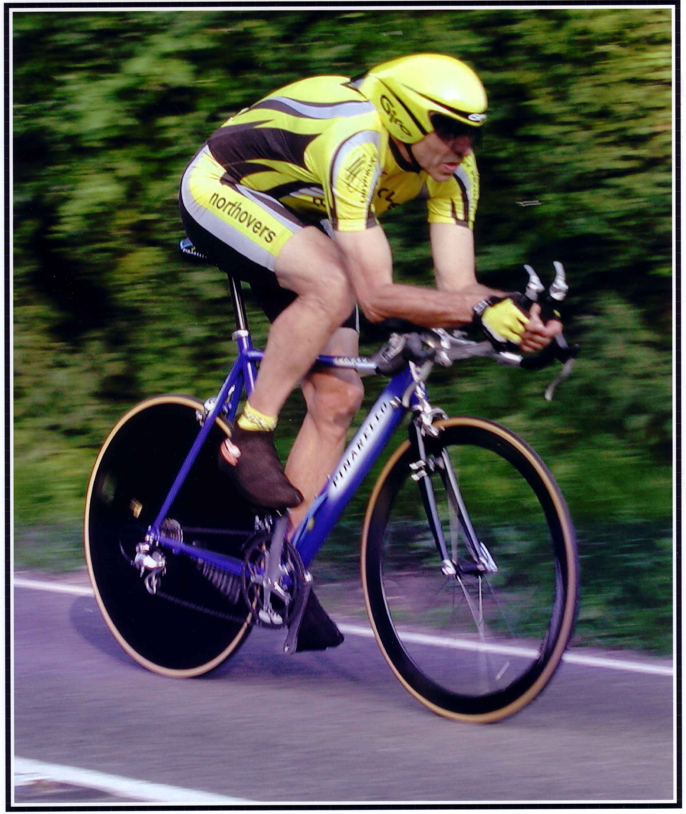

This Northover’s VT 10 Mile Solo & 2up TT is organised in memory
of our team-mate and good friend Bob Redrup who passed away unexpectedly on 26 September 2003 whilst on a training ride with the team prior to the
Duo Normandy in Marigny, France.
Easter Solo & 2Up 10 Mile Time Trial

Course Details: S26R/10

Start on old A30 at the lay-by approximately 200 yds East of Pattersons Cross, Feniton at a point 127 yds prior to the splay end of the lay-by. Proceed eastwards to go under the railway bridge and join the new A30 (care). Continue on the A30 to pass Honiton and at SECOND SLIP ROAD filter left (M) into slip road signed Dorchester. Crossover A30 and turn right (M) to re-join the A30 westbound. Pass Honiton and at slip road signed Otter Nurseries filter left to leave the A30, Give Way at base of the slip road and turn left onto the old A30 (M). Finish at a point 101 yds prior to the old railway bridge and some 200 yds short of the start point.

Please Call Number Loud and Clear When Finishing

Event HQ Organiser Timekeepers

Feniton Village Hall Tom Cox Andy Greatwood
Feniton, Nr Honiton 54 Graham Way Ray Pollard
Devon Cotford St Luke
Somerset TA4 1JG

If the car park is full in the village try to leave the church parking clear - it would be good if there is space near the church for the elderly residents to park. Thank you.

Directions to Start
Turn left out of the HQ, take left fork up hill, over bridge and take left at the T junction. After approx. ½ mile pass under the A30 dual carriageway to Pattersons Cross and turn left. The start will be in approx. 400yds on the left.

At completion of the event continue past the finish to Pattersons Cross and turn right under the dual carriageway and follow the reverse of the route back to the HQ.

Prize List Men- Solo
1st £30
2nd £25
3rd £20

Prize List Ladies
1st lady £30
2nd Lady 25
3rd Lady 20

1st Vet 40+ £10
1st Vet 50+ £10
1st Vet 60+ £10
1st Junior £10

Prize List – 2up
1st Club Team or Composite £30
2nd Club Team or Composite £25
3rd Club Team or Composite £20
NB: One Rider one Prize

Important Notes for Riders and Officials:-

- In the interests of your own safety Cycling Time Trail and the event promotors strongly advise riders wear a Hard Shell Helmet that meets approved international safety standards.

- Numbers will be at the Headquarters, please return them to the Headquarters when you have finished and ensure you sign out.

- Riders are to ensure that they read the course risk assessment, which will be next to the numbers at the HQ, prior to starting the event

- No U-Turns within sight of the Start and Finish Timekeepers

- Riders waiting to start must do so 20 yds before the Timekeeper and stand well to the left and in single file

- It is CTT Regulations that a working rear light, either flashing or constant, is fitted to the machine clearly visible to following road users and is active whilst the machine is in use. No working rear light NO RIDE!

- 2 up teams to have clothing of similar design & colour’s - for reference please refer to CTT handbook rules & regulations.

- The course used for this event is on a High-Speed road and filtering off to the left – be aware of this possibility every time you cross any exit road.

- Please ensure that when signing on you make sure you have looked at and read the on the day risk assessment and ensure that there are no additional hazards to be aware of prior to starting.

- Please note if parking underneath the new A30, which is approx. 400yds from the start. There is a private road opposite, this road is a private entrance to the farm and no parking is allowed on this road. This is a request from the farmer as he needs access to and from the farm at all times. If you are seen parking here you will be asked to move even if you are due to start in the next couple of minutes YOU HAVE BEEN WARNED. Thank you for you cooperation in advance.

Special Covid Regulations for the Running of Time Trials

Distance from HQ to start location: approx. 3 miles please leave enough time
to get to the start

IF YOU OR ANY OF YOUR HOUSEHOLD ARE NOT WELL OR ARE SHOWING SIGNS OF COVID-19 OR YOU LIVE IN A LOCAL LOCKDOWN AREA THEN PLEASE DO NOT COME TO THIS EVENT.

This event will be run under CTT’s current Covid-19 Risk Assessment. Please take time to read it

https://www.cyclingtimetrials.org.uk/documents/index/covid-19.

- Whilst there a few extra procedures outlined below, changes may be made based on events on the day. These will be communicated fully where appropriate. You are expected to heed the marshals.

- This event is run under CTT Rules and Regulations which can be found in full here: https://www.cyclingtimetrials.org.uk/articles/view/11

- The Event HQ has toilets which you may use but the changing facilities are not available, and please don’t inconvenience others by changing in the toilets. FACE MASKS TO BE WORN INSIDE unless you have a hidden disability which precludes you from wearing one. You will be required to maintain social distancing and observe hand-washing signs.

- Signing on and off, please sign on quickly take your number and go on return to sign out please place numbers in the box provided sign out and again depart.

- Please have respect for the person doing sign on / off and again wear a face covering unless you have a disability that precludes the use of one. If this is the case please make the official aware so they can move out of the way.

- The car parking spaces adjacent to the building are reserved for race officials. There is limited parking at the HQ and should you park on the road please ensure it is done with respect to locals.

- For signing on if the car park is full, park on the road come in sign on and move away.

- Please do not give the Feniton Village Hall reasons to regret hiring it to us.

- Your earliest arrival time is one and one quarter hours before your start. Please endeavour not to arrive at HQ before this. That might not be easy to organise, however, with the distance some of you will travel, we appreciate. If you arrive too early, you will be asked to stay in your vehicle. There will be no gatherings permitted in the carpark at less than the social distance.

- Turbo/trainer/roller warm-up is permitted in the HQ car park only and again provided social distance is maintained. Everyone must follow guidelines and instructions from officials, or they will not be permitted to race and will be reported to CTT.

- Local Lockdown to repeat: anyone who resides in or has an address within an affected area should not come to the event. The onus is on the rider to inform the organiser.

- Sign-On and Sign-off Sign-on for events is currently quite different to what we are used to. No handshakes, no hugging, no kissing and maintain social distance.

- There are some other restrictions in place. You will be expected to follow them. Remember: no rear light = no ride! We always expect you to respect the social distancing rules and maintain the legislated distance in all directions. We are all in this together so please respect the volunteer team and their decisions. Riders not adhering to the restrictions in place will not be permitted to race and will be reported to CTT. If you will not be starting, then please let us know by messaging Tom Cox on 07717 942632 as much in advance as possible. This helps the timekeepers and marshals.

- No pens will not be provided at sign-on so bring your own.

- No safety pins will be provided, so if you need them, you will need to bring your own.

- Riders will be required to sign out again please bring you own pen no signing out will result in the rider being DQ.

- Only arrive at the start 5 mins prior to your start time, and maintain social distancing guidelines. You will not be permitted to wait if you arrive earlier.

- Please note that no official at the start can take responsibility for any clothing left there.

- You are required to not answer the call of nature in the start area or change in sight of any residents and are not to leave a vehicle in the start layby.

- Spectators are not permitted.

- Riders are not permitted to warm up anywhere on the course one the event has started there is ample roads that can be used which avoid the need to use the course.

- The timekeepers and officials will be wearing face coverings where appropriate and checking riders have :- a) have their numbers attached correctly, b) have a working rear light,

- There will be no “pusher offer” and you will have to do a standing start on your own with one foot on the ground. Rolling starts, track stands and “jumping the gun” will not be permitted.

- If you catch up with another rider during your race, try to pass as quickly as possible and under no circumstances ride close behind so as to take shelter from the wind.

- Make it easy for the finish timekeepers: when you cross the line shout your number as loud as you can. Do not approach them at any point even if you wish to report you are DNF.

- Once you have finished you should return to the event HQ, sign out and then leave without congregating. There will be no catering. We realise this is not the norm and the social aspect of racing is a big part of the fun. However, we need to show we can follow these guidelines if we are to see time trials continue.

- Race Results and Prize Presentation Race results will not be available at the event, so please do not ask. We will collate the results and post them online ASAP on the CTT website and media channels. We will then email the participants using the address supplied in the usual manner. Neither will there be a prize presentation and award ceremony; prizes etc. will be posted. This is to encourage prompt dispersal.

- Refreshments: - To ensure we comply with the government regulations, the CTT guidance and Covid-19 Risk Assessment, there will be no catering on offer by us.

- Under 18s:- Those under 18 on the day of the event will require a hard copy parental consent form. Numbers will not be issued to under-18s unless the form is presented – no number = no ride, unfortunately. The appropriate form is available on the CTT website https://www.cyclingtimetrials.org.uk/documents/index/guardians

- This Document has been based on that used for the National 100 on the 16th August, it works please do not give any non-cyclist, local resident or any member of the general public the opportunity to complain. Remember we are lucky in that our sport is able to continue in the current climate all be it slightly different many other sports cannot at present.

Thank you for your cooperation!

